5. Project Development Phase
Objective

To implement the designed Auto Ticket Classification workflow using Flow Designer and configure the required triggers, conditions, and actions.

Activities Performed

- Open the Flow Designer environment.
- Create a new flow for ticket classification.
- Configure the flow trigger.
- Select the appropriate ticket table.
- Configure the condition for newly created tickets.
- Add classification conditions.
- Configure category assignment actions.
- Configure support group assignment actions.
- Configure ticket update actions.
- Save and activate the flow.
- Verify the flow configuration.

Flow Development

The flow is developed using the following sequence:

Trigger → Condition → Classification → Assignment → Update

Trigger

The flow is configured to start when a new support ticket is created.

Conditions

Conditions are configured to identify the type of issue from the available ticket information.

For example:

- Access-related issue
- Hardware-related issue
- Software-related issue
- Network-related issue

Actions

After identifying the ticket type, the flow performs the required actions:

- Update ticket category.
- Assign the appropriate support group.
- Update relevant ticket information.
- Continue the workflow to completion.

Expected / Produced Output

A working Flow Designer automation is produced that can automatically classify and route support tickets based on predefined conditions.

Workflow

New Ticket → Trigger → Check Ticket Details → Apply Condition → Assign Category → Assign Group → Update Ticket → End

Screenshots

Screenshot 1
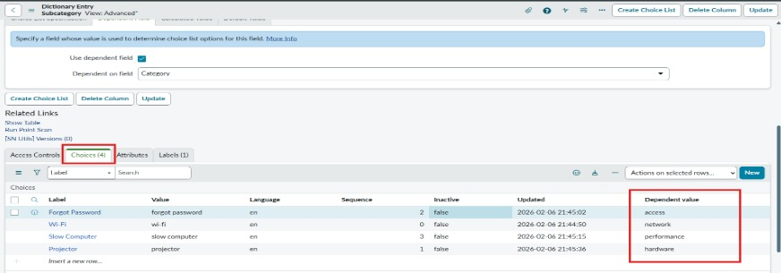
Screenshot 2
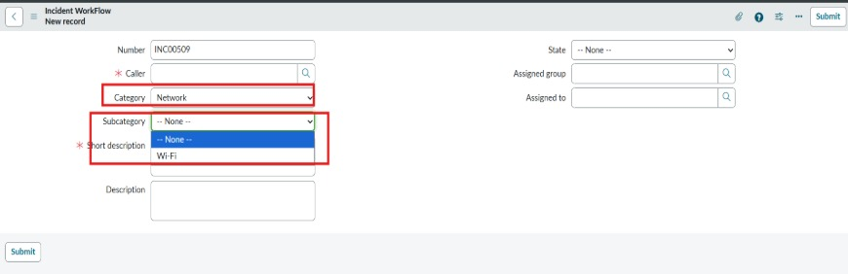
Screenshot 3
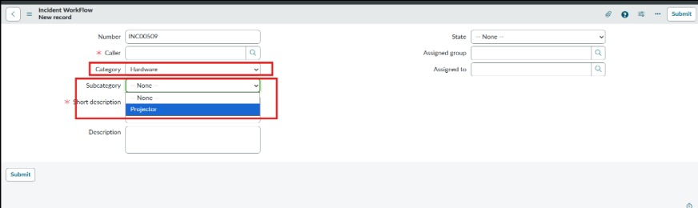
Screenshot 4
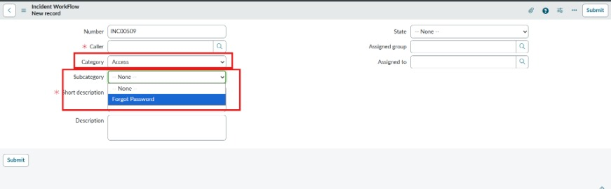
Screenshot 5
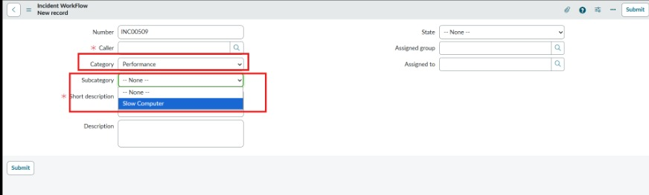
Data Flow Diagram

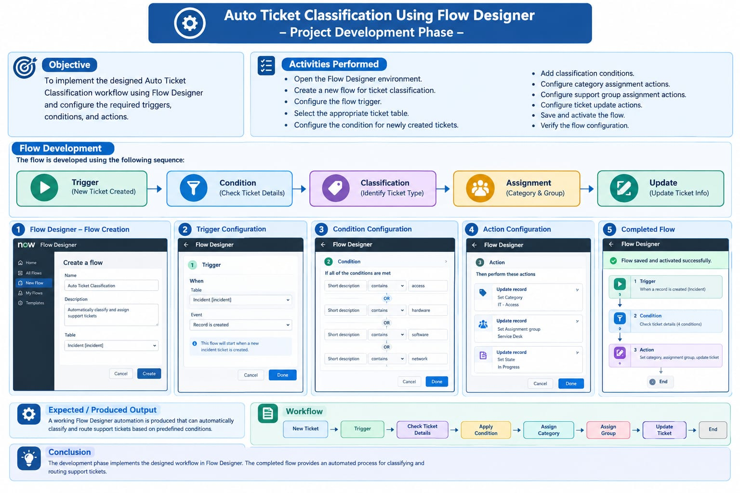

Conclusion

The development phase implements the designed workflow in Flow Designer. The completed flow provides an automated process for classifying and routing support tickets.

